Comparative tests on the pipe heat emission

1. General data
Carrying out comparative test of the pipe heat emission was carried out by the staff of the test center "Stroytest-SIBADI" by the request of OOO Spetsialnye tekhnologii.

The goal of the work was the determination of density of a heat flow from the heat isolated (two layers of Isollat) and not heat isolated pipe with a diameter of 160 mm.

2. Test conditions
The scheme and the general view of the experiment are presented below:
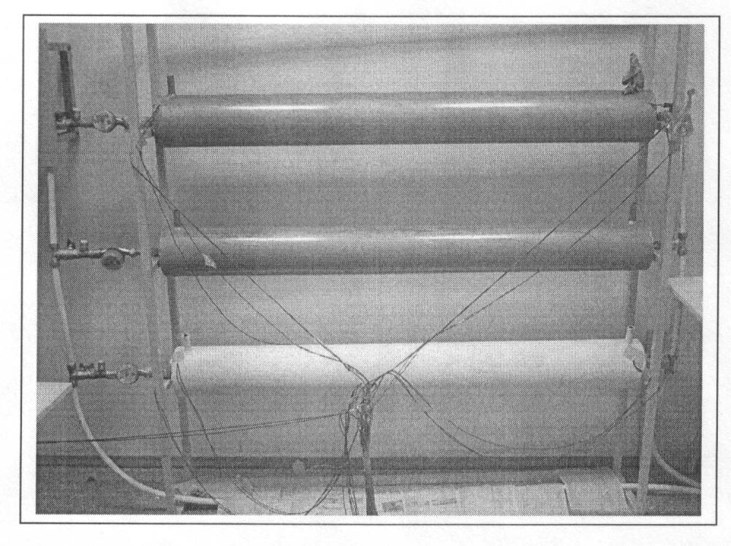
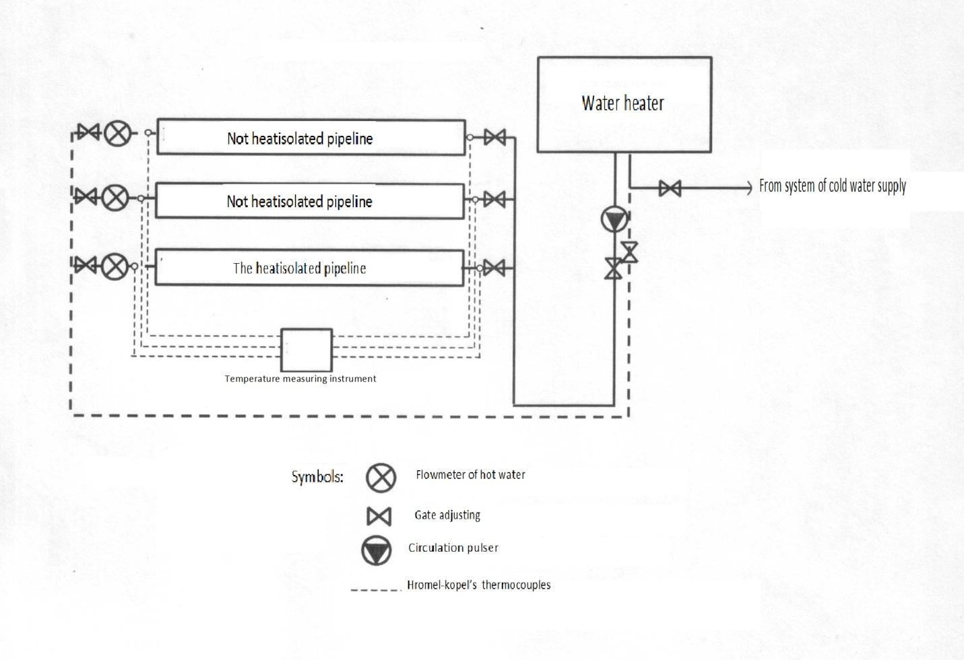

Thermocouples
Pump
Spherical tap
Flowmeter

The test bench represents three pipes with diameter of 160 millimeters, 1,5 meters long, located one above another and connected by means of metal-plastic pipelines. The flow is carried out by spherical taps. Capacity of the water heater is of 50 liters. Continuous circulation of water is provided by the WILO circulation pump installed on the supply pipeline. The top tube is not connected with the return pipeline and used just to assure the complete filling of the down tubes.

Tests were carried out at the stationary temperature condition and a constant flow of the coolant within 12 hours. The criterion of the stationary mode was the constant temperature of the coolant in the controlled points at the beginning and the end of the tested pipe during two hours.

The water heated by an accumulative water heater of 50 liters volume passes a supply pipeline, examined pipe, and comes back to the heater by the return pipeline. The measurement on isolated and non-isolated pipes is made separately, with one of the pipes excluded from the experiment with the help of taps. Water flow is measured by the flowmeter installed in the output of the tested pipe.

Tests were carried out at an average temperature of ambient air of +28.1 C.

3. Tests results:
Detailed results of tests are presented in the table below:

Parameters | Heat isolated pipe |  |  | Heat non-isolated pipe
 | test 1 | test 2 | test 3 | test 1 | test 2 |  | test 3
Average ambient temperature, ⁰С | 28,1 |  |  | 28,1
Water temperature t₁ at the tested pipe input, ⁰С:  1 measurement  2 measurement  3 measurement  Average temperature, ⁰С | 77,1  77,1  77,1  77,1 | 77,1  77,1  77,1  77,1 | 77,2  77,3  77,3  77,3 | 76,9  77,0  77,0  77,0 |  | 77,0  77,0  77,0  77,0 |  | 77,3  77,0  77,1  77,1
Water temperature t₂ at the pipe output, ⁰С:  1 measurement  2 measurement  3 measurement  Average temperature, ⁰С | 75,0  75,1  75,3  75,1 | 75,3  75,2  75,2  75,2 | 75,4  75,5  75,2  75,2 | 71,3  71,3  71,3  71,3 |  | 71,3  71,4  71,3  71,3 |  | 71,3  71,3  71,3  71,3
Average temperature difference, ⁰С | 2,0 | 1,9 | 1,9 | 5,7 |  | 5,7 |  | 5,8
Surface temperature of the pipe , ⁰С:  1 measurement  2 measurement | 67,4  63,8 | 67,4  63,7 | 67,5  64,1 | 71,3  70,2 |  | 70,9  70,3 |  | 71,0  70,5
Water flow G, kg/hour | 115,5 | 115,4 | 114,3 | 114,1 |  | 114,2 |  | 114,2
Full heat flow Q from the pipe, Watt | 269 | 255 | 253 | 756 |  | 757 |  | 770
Averaged by pipe length heat flow density q, Watt/m² | 358 | 340 | 337 | 1006 |  | 1009 |  | 1027
Average heat flow density from the tested pipe, Watt/m² | 345 |  |  | 1014

Here the full heat flow Q is calculated through the coolant energy losses:
Q = G * C *(t ₁ – t ₂) /3.6 Watt,
where C = 4,187 kJ/kg*grad is the water heat capacity.

Averaged by pipe length heat flow density q is a heat flow through 1 m², that is
q = Q/S Watt/m²,
where S = 0.75 m² is the surface of the tested pipe.

4. Conclusions
For the technical reasons the measurements are done with the help of the slow laminar flow. It is known that in such conditions the heat exchange is not intensive. Even in this case the two layer Isollat protection assures a three-fold drop in the energy losses.
In the real situation with the turbulent flow the economy will be bigger.

